**-Do you agree or disagree the following statement?**

**The more money a person has, the more should he or she give away to charities.**

|  |  |
| --- | --- |
| **Agree -more … more** | **Disagree – X more … more/ decide on one’s own** |
| Reason 1 | Reason 1 |
| Reason 2 | Reason 2 |
| Reason 3 (or concession) | Reason 3(or concession) |

**Sample 1:**

Our sophisticated modern society, giving rise to a growing awareness of freedom of opinions and choices, provides each citizen with ingredients for hard work, prominence, and happiness. It comes as no surprise that people strive for their dream, for the sake of finding happiness. On the other hand, opinions could vary dramatically, in face of numerous choices and changes. When it comes to the issue whether wealthier person should donate more money to charity, opinions diverge greatly. In my perspective, l agree with the statement that 补充完整. (95) hook（需要改）+ 改写题目+我的观点

Analyze the opening paragraph:

Words and expressions to learn:

First of all, considering their financial situation, rich people can spend more money on such charity activities or even participate in them. 解释：rich有结余，在保证自己日常生活、生产运营的情况下，有大量的盈余，存在银行或者投资赚更多的钱，都对自己的生活没有大的影响，能够很容易分出来一部分去帮助他人。The amount of money they can pay may help the charity to facilitate its activities. Owing to the fact that ordinary people cannot spend too much on such activities, it is less likely that they can contribute more. However, if rich people consider spending a regular big amount of money, charities can start their funding programs and as a result poor people will benefit sooner. Since such amount of money is not a big deal to the rich as to the poor, it won’t bring as much opportunity cost to the rich to donate such money. ~~On the other hand, the rich will benefit from reduction of tax and a better reputation, which will bring further benefits to his/her business. Therefore, they should donate more money to the charity.~~ (151)

Analyze the 1st body paragraph:

Words and expressions to learn:

Secondly, richer people donating more to charities ~~influential people~~ can actually make a positive impact on the community. As affluent people can be successful in different fields, they can inspire people by building a good image of themselves. 数据论证：1mn 捐1w，1%； 1bn捐 1kw，也是1%。 越有钱捐得越多，对于普通人来说是一种inspiration，everyone can do their bit to their society according to their financial ability, so does ordinary people with average incomes. ~~And people will always keep an optimistic attitude and a thankful heart whenever they face difficulties or at the time overcome them.~~ A recent survey conducted in my community showed that 78.8% people would contribute more to charity when they see ~~an influential local celebrity~~ donating money to local charity programs. They attribute this choice to the fact that they will trust the charity program more if the credible wealthy person donates the money. It’s human nature that we follow examples. (116)

Analyze the 2nd body paragraph:

Words and expressions to learn:

Lastly, the practice/ move of richer people giving more money to others can actually benefit the wealthy themselves per se. 解释benefit，进行分类；

Analyze the 3rd body paragraph:

Words and expressions to learn:

~~rich people often need to advertise for themselves or their industry. There has been bias toward rich people and charity is a common way for celebrities to advertise themselves. lt is not only they give out money but at the same time, they can gain more awareness, get invited to more television shows or newspaper. Thus, instead of investing in advertisements, rich people could donate this money to charity to build positive images, and such acts could also help them recruit more loyal employees, receive more tax reductions, and build stronger ties with local governments and local people. Thus, they should devote more to the charity.~~ (118) 举例： 白象方便面 + 鸿星尔克

Overall, as reasons presented above, it is better for rich people to give away more money to charities as it is considered to be one of their responsibilities and could also benefit themselves. (42) (492) 总结全文+ 重申观点+改写理由

Analyze the ending paragraph:

Words and expressions to learn:

**General comments:**

**Do you agree or disagree with the following statement? The more money people have, the more they should contribute to charity?**

**Sample 2:**

People are constantly driven by greed to pursue wealth. As celebrities gradually become some of the top-earning people in the country, they are also condemned for misusing their wealth. While people hold control over the money earned through hard work, as members of the interconnected society, they should be conscious of their responsibility in giving back to society in the form of charity and contribute proportionally to their wealth. As people earn more, they have more money that is not urgently needed and therefore should put them to good use. No matter how luxurious one lives, there is an upper limit to the amount of money needed to purchase the essentials. After people have a comfortable house and enough money to satisfy their basic needs, they store the leftover money in the bank. While they think they may need it for emergent situations，it is often left useless in banking accounts. Bill Gates is a well-known philanthropist who is truly dedicated to putting his money to good use. He lives by a relatively extravagant lifestyle with numerous fancy estates and all the goods you can only dream of. Nevertheless, he knows he already has all the money he ever needs and decided to distribute the money left idle to those in need. When an individual earns more, the more they leave unused. They should and can afford to take advantage of their wealth and utilize it for a good cause.

Analyze the sample and offer your ideas on its merits and demerits.

Words and expressions to learn：

Those who earn more money are responsible for giving back because they earned it from the people. There is only a limited amount of money circulating amongst society at a certain time. Therefore, those who are rich did not make money out of thin air but are rather skilled in relocating money into the pockets. An obvious example would be a company that makes products, such as Apple making money off of iPhones or Airpods from customers. Another example would be stockbrokers making money by tricking desperate people eager to earn money through investment into buying unrewarding stocks. One way or another, people make money off of each other, and those who earn more from others should give back the portion they do not need back to those they “stole” it from.

There is an ever-growing desire to purchase extravagant but unnecessary goods. However, since all the unfortunate and fortunate that occur to one’s life are due to each other’s

impacts, those who take more from the people are also responsible for giving it back to those needing it. 437

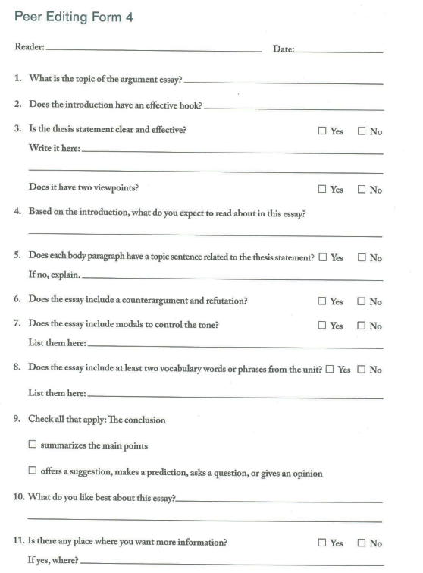

**Homework:**

1. Please write a full piece on your own, or if challenging, ask for peers to collaborate into a full piece. Put all your names and contributions on the paper.

2. Brainstorming for similar prompts:

1. 20191201 下午 - 独立写作: 在 charitable organization 捐钱的时候，应该由人们自己决定钱最终要捐给谁，还是由慈善组织决定?

2. 20220917 上午 - 独立写作

Do you agree or disagree with the following statement? People are happier when they give away extra money to charity or a good cause rather than when they spend it on themselves.

3. 20210526 - 独立写作 20201010

When you give money to the charitable organizations, would you prefer to choose how the donation will be used (for example, donate money on food, service or advertisement for organizations) or leave the decision to the organizations?